|  |  |  |
| --- | --- | --- |
| **DEVOPS TRAINING** | | |
| Configure Python environment on Linux | | |
| Author: | Aleksandr Merkushkin  [Alexander_Merkuhkin@epam.com](mailto:Alexander_Merkuhkin@epam.com) |
| Mentor: | Alexey Pankratov  [Alexey_Pankratov@epam.com](mailto:Alexey_Pankratov@epam.com) |
| Date: 10.09.2020 |  |

**Contents**

Tasks…………………………………………………………………………………………………………………….3

Task 1...……………………………………………………………………………………………………………..…5

**Tasks**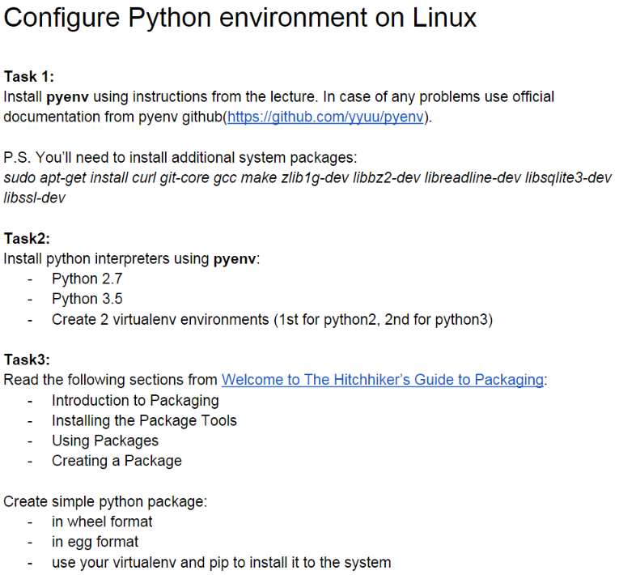

**Task 1.**

yum install curl git­core gcc make zlib1g­dev libbz2­dev libreadline­dev libsqlite3­dev libssl­dev

yum groupinstall -y "Development Tools" "Development Libraries"

yum install -y python3-devel

yum -y install epel-release

curl -L https://raw.github.com/yyuu/pyenv-installer/master/bin/pyenv-

installer | bash

yum install -y python36

в bashrc

|  |
| --- |
| echo ' |
|  | export PYENV_ROOT="$HOME/.pyenv" |
|  | export PATH="$PYENV_ROOT/bin:$PATH" |
|  | eval "$(pyenv init -)" |
|  | eval "$(pyenv virtualenv-init -)" |
|  | ' >> ~/.bashrc |
|  | source ~/.bashrc |

yum install zlib-devel

pyenv install 2.7.8

